**Name: Gaurav Kumar Singh**

**Registration Number: 19BCE2119**

**Course: Web Technology (ITE-1002) L11-12**

**Digital Assignment – 3**

1. **CODE:**

<html>

<head>

    <script src="http://ajax.googleapis.com/ajax/libs/jquery/3.3.1/jquery.min.js"></script>

    <meta name="viewport" content="width=device-width">

    <style>

        table,

        td {

            border: 1px solid black;

            margin: 5%;

            font-family: "Trebuchet MS", Arial,

                Helvetica, sans-serif;

        }

        tr:hover {

            background-color: #ddd;

        }

        td {

            padding: 10px;

            padding-bottom: 12px;

            text-align: left;

            color: black;

        }

        th {

            padding-top: 10px;

            padding-bottom: 10px;

            text-align: left;

            background-color: #f2a0e9;

            color: white;

        }

    </style>

    <script>

        $(document).ready(function () {

            $("#submit").click(function () {

                details = [{

                    "Student": $("#Student").val(),

                    "student_name": $("#student_name").val(),

                    "P_NAME": {

                        "Mname": $("#Mname").val(),

                        "Pname": $("#Pname").val(),

                    },

                    "dob": {

                        "date": $("#date").val(),

                        "month": $("#month").val(),

                        "year": $("#year").val(),

                    },

                    "blood": $("#blood").val(),

                    "email": $("#email").val(),

                    "phone": {

                        "m": $("#m").val(),

                        "l": $("#l").val(),

                    },

                    "address": {

                        "dno": $("#dno").val(),

                        "street": $("#street").val(),

                        "place": $("#place").val(),

                        "pin": $("#pin").val(),

                        "country": $("#country").val(),

                    },

                    "degree": $("#degree").val(),

                }];

                var tbl = $("<table/>").attr("id", "mytable");

                var tblr1 = "<thead><tr><th>ID</th><th>Student name < /th><th>Parents Name</th > < th > DOB < /th><th> Blood Group </th > < th >Email < /th><th> Phone </th > < th > Address < /th><th> Degree </th > </tr> </thead > ";

                $("#div1").append(tbl);

                $("#mytable").append(tblr1);

                for (var i = 0; i <

                    details.length; i++) {

                    var tr = "<tr>";

                    var td = "<td>" + details[i]["Student"] +

                        "</td>";

                    var td1 = "<td>" + details[i]["student_name"] + "</td>";

                    var td2 = "<td>" + "MOM: " + details[i]["P_NAME"]["Mname"] + " DAD: " +

                        details[i]["P_NAME"]["Pname"] + "</td>";

                    var td3 = "<td>" + details[i]["dob"]["date"] + "-" + details[i]["dob"]["month"] +

                        "-" +

                        details[i]["dob"]["year"] + "</td>";

                    var td4 = "<td>" + details[i]["blood"] + "</td>";

                    var td5 = "<td>" + details[i]["email"] + "</td>";

                    var td6 = "<td>" + details[i]["phone"]["m"] + " " + details[i]["phone"]["l"] +

                        "</td>";

                    var td7 = "<td>" + details[i]["address"]["dno"] + " ," + details[i]["address"][

                            "street"

                        ] +

                        ", " + details[i]["address"]["place"] + " ," + details[i]["address"]["pin"] +

                        " ," +

                        details[i]["address"]["country"] + "</td>";

                    var td8 = "<td>" + details[i]["degree"] +

                        "</td>";

                    $("#mytable").append(tr + td + td1 + td2 + td3 + td4 + td5 + td6 + td7 + td8);

                }

            });

        });

    </script>

</head>

<body>

    <h1>STUDENT DETAILS</h1>

    <table style="border: 1px solid black;" id="detail_table">

        <form id="form1" class="form1class" action="">

            <tr>

                <td><label for="student_name">Name: </label></td>

                <td><input type="text" id="student_name" placeholder="Enter your name" required></td>

            </tr>

            <tr>

                <td><label for="P_NAME">Parents name </label></td>

                <td><input type="text" id="Mname" placeholder="Enter your Mothers name" required></td>

                <td><input type="text" id="Pname" placeholder="Enter your Fathers name" required></td>

            </tr>

            <tr>

                <td><label for="dob">Date of Birth: </label></td>

                <td><input type="number" id="date" required placeholder="dd"></td>

                <td><input type="number" id="month" required placeholder="mm"></td>

                <td><input type="number" id="year" required placeholder="yyyy"></td>

            </tr>

            <tr>

                <td><label for="blood">Blood group:</label></td>

                <td><input type="text" id="blood" required></td>

            </tr>

            <tr>

                <td><label for="email">Email:</label></td>

                <td><input type="email" id="email" required></td>

            </tr>

            <tr>

                <td><label for="phone">Phone number:</label></td>

                <td><input type="tel" id="m" placeholder=" Enter mobile" required></td>

                <td><input type="tel" id="l" placeholder=" Enter landline" required></td>

            </tr>

            <tr>

                <td><label for="address">Address</label></td>

                <td><input type="number" id="dno" placeholder="Enter door no" required></td>

                <td><input type="text" id="street" placeholder="Enter street name" required></td>

                <td><input type="text" id="place" placeholder="Enter place name" required></td>

                <td><input type="number" id="pin" placeholder="Enter pin code" required></td>

                <td><input type="text" id="country" placeholder="Enter country" required></td>

            </tr>

            <tr>

                <td><label for="degree">Degree:</label></td>

                <td><input type="text" id="degree" required></td>

            </tr>

            <tr style="align-items: center;">

                <td colspan="8"><input type="button" value="Submit" id="submit" name="submitbutton"></td> </tr> </form>

                        </table> <p id="display"></p>

                    <div id="div1"></div>

</body>

</html>

**SCREENSHOTS:**

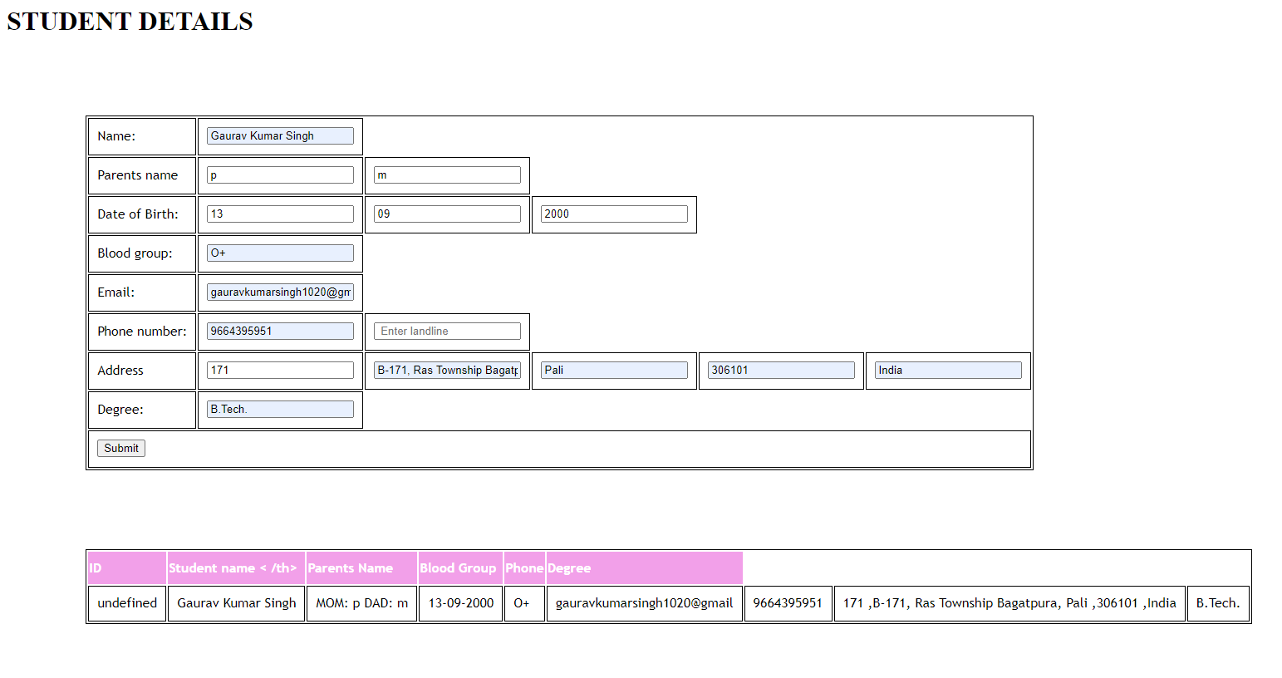

1. **CODE:**

<!DOCTYPE html>

<html>

<script src="https://ajax.googleapis.com/ajax/libs/angularjs/1.6.9/angular.min.js"></script>

<link rel="stylesheet" href="https://www.w3schools.com/w3css/4/w3.css">

<body>

<script>

var app = angular.module("myShoppingList", []);

app.controller("myCtrl", function($scope) {

    $scope.products = [];

    $scope.addItem = function () {

        $scope.errortext = "";

        if (!$scope.addMe) {return;}

        if ($scope.products.indexOf($scope.addMe) == -1) {

            $scope.products.push($scope.addMe);

        } else {

            $scope.errortext = "The item is already in your shopping list.";

        }

    }

    $scope.removeItem = function (x) {

        $scope.errortext = "";

        $scope.products.splice(x, 1);

    }

});

</script>

<div ng-app="myShoppingList" ng-cloak ng-controller="myCtrl" class="w3-card-2 w3-margin" style="max-width:400px;">

  <header class="w3-container w3-light-grey w3-padding-16">

    <h3>My Shopping List</h3>

  </header>

  <ul class="w3-ul">

    <li ng-repeat="x in products" class="w3-padding-16">{{x}}<span ng-click="removeItem($index)" style="cursor:pointer;" class="w3-right w3-margin-right">×</span></li>

  </ul>

  <div class="w3-container w3-light-grey w3-padding-16">

    <div class="w3-row w3-margin-top">

      <div class="w3-col s10">

        <input placeholder="Add shopping items here" ng-model="addMe" class="w3-input w3-border w3-padding">

      </div>

      <div class="w3-col s2">

        <button ng-click="addItem()" class="w3-btn w3-padding w3-green">Add</button>

      </div>

    </div>

    <p class="w3-text-red">{{errortext}}</p>

  </div>

</div>

</body>

</html>

**SCREENSHOTS:**

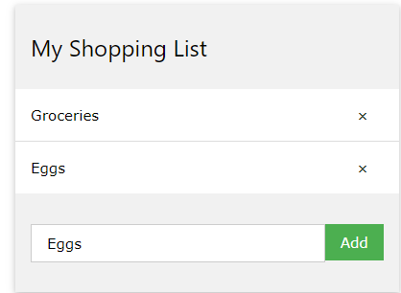

1. **CODE:**

<!DOCTYPE html>

<html lang="en">

<head>

    <meta charset="UTF-8">

    <meta http-equiv="X-UA-Compatible" content="IE=edge">

    <meta name="viewport" content="width=device-width, initial-scale=1.0">

    <title>Document</title>

</head>

<body>

    <div>

        <form method=GET>

            <label for="products">Choose a product:</label>

            <select name="products" id="products">

            </select>

            <option></option>

            <br><br>

            <button type=button id=btn>Check</button>

        </form>

    </div>

    <div>

        <table id=table>

            <thead>

                <th>ProductID</th>

                <th>Name</th>

                <th>Price</th>

                <th>Stock</th>

                <th>Type</th>

            </thead>

            <tbody>

            </tbody>

        </table>

    </div>

    <script type="text/javascript" src="http://ajax.googleapis.com/ajax/libs/jquery/1.6.2/jquery.min.js"> </script>

    <script>

        var X

        var fun= async ()=>{

            let dropdown = await $('#products');

            console.log(dropdown.length)

            dropdown.empty();

            dropdown.append('<option selected="true" disabled>Choose product</option>');

            dropdown.prop('selectedIndex', 0);

            await $.getJSON('3.json', function (data) {

                console.log(data.Products)

                X=data.Products

            })

            $.each(X, (key, entry)=>{

                console.log(entry.name)

                dropdown.append($('<option></option>').attr('value', entry.ProductID).text(entry.name));

            });

        }

        fun()

        $('#btn').click(()=>{

            $('#table tbody').empty();

            var val=$("form").serializeArray();

            console.log(val[0].value)

            var pid=val[0].value;

            for (var i=0; i<X.length; i++){

                if(pid==X[i].ProductID){

                    $('tbody').append('<tr><td>'+X[i].ProductID+'</td><td>'+X[i].name+'</td><td>'+X[i].price+'</td>'+'<td>'+X[i].stock+'</td>'+'<td>'+X[i].type+'</td>'+'</tr>')

                }

            }

        })

    </script>

</body>

</html>

**JSON FILE:**

{

    "Products": [

        {

            "ProductID": "1",

            "name": "A",

            "price": "10",

            "stock": "10",

            "type": "z"

        },

        {

            "ProductID": "2",

            "name": "B",

            "price": "20",

            "stock": "20",

            "type": "y"

        },

        {

            "ProductID": "3",

            "name": "C",

            "price": "30",

            "stock": "30",

            "type": "x"

        }

    ]

}

**SCREENSHOTS:**

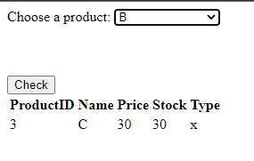

1. **CODE:**

<!DOCTYPE html>

<html>

<script src="https://ajax.googleapis.com/ajax/libs/angularjs/1.6.9/angular.min.js"></script>

<body>

<h2>Validation</h2>

<form ng-app="myApp" ng-controller="validateCtrl"

name="myForm" novalidate>

<p>Your Name (required)<br>

<input type="text" name="user" ng-model="user" required>

<span style="color:red" ng-show="myForm.user.$dirty && myForm.user.$invalid">

<span ng-show="myForm.user.$error.required">Name is required.</span>

</span>

</p>

<p>Your Email (required)<br>

<input type="email" name="email" ng-model="email" required>

<span style="color:red" ng-show="myForm.email.$dirty && myForm.email.$invalid">

<span ng-show="myForm.email.$error.required">Email is required.</span>

<span ng-show="myForm.email.$error.email">Invalid email address.</span>

</span>

</p>

<p>Your Phone <br>

    <input type="text" name="phone" ng-model="phone" ng-pattern="/^[0-9]{10}$/" required>

    <span style="color:red" ng-show="myForm.phone.$dirty && myForm.phone.$invalid">

    <span ng-show="myForm.phone.$error.required">Phone number is required.</span>

    <span ng-show="myForm.phone.$error.pattern">Phone number is invalid.</span>

    </span>

</p>

<p>Website<br>

    <input type="text" name="url" ng-model="url" ng-pattern="/[-a-zA-Z0-9@:%_\+.~#?&//=]{2,256}\.[a-z]{2,4}\b(\/[-a-zA-Z0-9@:%_\+.~#?&//=]*)?/" required>

    <span style="color:red" ng-show="myForm.url.$dirty && myForm.url.$invalid">

    <span ng-show="myForm.url.$error.required">Website is required.</span>

    <span ng-show="myForm.url.$error.pattern">Website is invalid.</span>

    </span>

</p>

<p>Credit Card<br>

    <input type="text" name="card" ng-model="card" ng-pattern="/^[0-9]{18}$/" required>

    <span style="color:red" ng-show="myForm.card.$dirty && myForm.card.$invalid">

    <span ng-show="myForm.card.$error.required">Credit card number is required.</span>

    <span ng-show="myForm.card.$error.pattern">Credit card number is invalid.</span>

    </span>

</p>

<p>Date<br>

    <input type="text" name="date" ng-model="date" ng-pattern="/^(0?[1-9]|[12][0-9]|3[01])[\/\-](0?[1-9]|1[012])[\/\-]\d{4}$/" required>

    <span style="color:red" ng-show="myForm.date.$dirty && myForm.date.$invalid">

    <span ng-show="myForm.date.$error.required">Date is required.</span>

    <span ng-show="myForm.date.$error.pattern">Date is invalid.</span>

    </span>

</p>

<p>

<input type="submit"

ng-disabled="myForm.user.$dirty && myForm.user.$invalid ||

myForm.email.$dirty && myForm.email.$invalid || myForm.phone.$dirty && myForm.phone.$invalid || myForm.url.$dirty && myForm.url.$invalid

|| myForm.card.$dirty && myForm.card.$invalid || myForm.date.$dirty && myForm.date.$invalid">

</p>

</form>

<script>

var app = angular.module('myApp', []);

app.controller('validateCtrl', function($scope) {

    $scope.user = "Gaurav"

    $scope.email = "gauravkumar.singh2019@vitstudent.ac.in"

    $scope.phone = "9664395951"

    $scope.url = "";

    $scope.card =  "111111111111111111";

    $scope.date = ""

});

</script>

</body>

</html>

**SCREENSHOTS:**

